Working Paper #21
From Preschool to Politics: Early Socialization in Tulsa
EARLY CHILDHOOD RESEARCH QUARTERLY (forthcoming)

Karin Kitchens and William Gormley
September, 2022
Highlights
- Pre-K is associated with increased academic skills and self-regulation.
- Both academic skills and self-regulation are linked to voting.
- Pre-K is associated with an increased likelihood to register to vote and actually vote.
Abstract
Voting in an election can be a complicated process, requiring both knowledge and motivation. According to the “primacy principle” and theories of “human capital formation,” early childhood learning has the potential to shape attitudes and behaviors later in life. If correct, these theories suggest that early childhood education could help develop skills necessary for voting. Using data from Tulsa Public Schools (TPS), we identify 4,033 students who entered kindergarten in the fall of 2006. Approximately half of those students were enrolled in universal pre-K the year before. We then identify which of these students registered to vote and actually voted in the two years after they turned 18. Using propensity score weighting, we find that students enrolled in pre-K were more likely to register to vote and to vote in an election than those not enrolled in pre-K. We explore potential paths through which pre-K might increase civic participation. We find that pre-K increases both cognitive and socio-emotional skills and that an increase in these skills is associated with an increase in registering to vote (cognitive) and actual voting (cognitive and socio-emotional).
Keywords
Pre-K, academic skills, self-regulation, voting

WORKING PAPERS
Working papers disseminated by CROCUS are intended to stimulate discussion and debate, prior to the publication of a paper in a peer-reviewed journal. Working papers may be cited. They may also be quoted with the lead author’s permission.

Pre-K and Voter Registration
In recent years, many empirical studies have established that children benefit in the short run from high-quality early childhood education programs (Yoshikawa et al., 2013; Phillips et al., 2017). Although effects diminish over time (Duncan and Magnuson, 2013), and some studies find no effects as of third grade (Puma et al., 2012; Lipsey et al., 2018), considerable evidence suggests that both targeted and universal pre-K programs yield long-term benefits for children (McCoy et al., 2017; Gormley et al., 2018; Gray-Lobe et al., 2021), provided that certain conditions are met.
Although many evaluations of early childhood education programs have focused on cognitive outcomes such as student performance on standardized test scores, some scholars have included socio-emotional outcomes in their analysis (Gormley et al., 2011; Weiland & Yoshikawa, 2013; Bierman et al., 2014). Perry Preschool studies have included a wide variety of long-term outcomes, including voter registration and voting (Schweinhart & Weikart, 1997). An influential reanalysis of the Perry Preschool Program found that some of Perry’s long-term effects are attributable to improved character skills that increased academic motivation and reduced negative externalizing behaviors (Heckman et al., 2013).
Since Perry, very little attention has been paid to the civic consequences of strong early childhood education programs, perhaps because that is seldom an explicit focus of preschool education. However, Holbein has examined the civic consequences of a strong early childhood education program that emphasizes socio-emotional development in a multi-year curriculum that began in 1st grade. Exposure to that elementary school intervention, Holbein (2017) shows, encourages program participants to register to vote and to actually vote as young adults. Reflecting on this research, Campbell (2019: 43) observes, “Even interventions that seem far removed from civics can nonetheless foster greater civic engagement.”
In this paper, we ask whether a large, high-quality, universal pre-K program in Tulsa, Oklahoma has any long-term consequences for voter registration or voter turnout. We explicitly consider the possibility that early childhood education strengthens the cognitive and socio-emotional skills that facilitate civic engagement. Using data from Tulsa Public Schools (TPS), we identify who was enrolled in kindergarten in 2006. Approximately half of those students were enrolled in universal pre-K the year prior. We then identify which of these students registered to vote in the two years after they turned 18. Using propensity score weighting, we find that students enrolled in pre-K were more likely to register to vote and vote in an election than those not enrolled in pre-K. Using path models, we explore potential paths, cognitive and socio-emotional skills or traits, through which pre-K might increase civic participation. We find that pre-K increases both cognitive and socio-emotional skills and in turn an increase in these skills is associated with an increase in registering to vote. We find that an increase in cognitive skills is associated with an increased likelihood in registering to vote and an increase in both cognitive and socio-emotional skills is associated with an increased likelihood of actual voting.
Theoretical Foundations
Both ecological and socio-cultural models of human development posit that young children learn from “proximal” sources such as parents, teachers, and peers how to think, how to behave, how to solve problems, and how to interact with others (Bronfenbrenner, 1979; Vygotsky, 1978). Children are active partners in interactions with educators, but they are not infinitely malleable. Educators should take the child’s age and capacity into account, recognizing that skills, to be acquired, must lie within the child’s “zone of proximal development.” Learning is an ongoing process, but the early years (0-5) are of critical importance.
Economics sharpens our understanding and appreciation of the early years, thanks to such concepts as “human capital” and “dynamic complementarities.” Skills acquired prior to a given intervention should, in principle, increase that intervention’s likelihood of success. A key role of early skill development (whether cognitive or socio-emotional) is to boost the probability that one experience will enhance the utility of another. The dynamic complementarities hypothesis suggests that treatment group children will develop at more rapid rates, as early skills facilitate the acquisition of later skills (Cunha and Heckman, 2007). On the other hand, a dynamic substitutability hypothesis suggests that control group children may be exposed to other learning growth opportunities that replicate the early advantages that treatment group children enjoyed.
Young children must develop many different kinds of skills if they are to flourish in school, at home, and in the community. The list includes language skills, math skills, critical thinking skills, social skills, small motor skills, and gross motor skills, among others. A high-quality preschool program can play a significant role in promoting such skills, and elementary and secondary schools can play a significant role in sustaining them. Clearly, settings matter. Ideally, a preschool program lays the groundwork for skills that will be useful later in life (Heckman, 2000).
From a political science perspective, the “primacy principle” is a way of linking the early childhood literature to political socialization and, eventually, to adult political participation. In a nutshell, the primacy principle states that children acquire fundamental political orientations at an early age and that these orientations persist over time (Searing, Wright, & Rabinowitz, 1976). They include, among others, political party identification, political efficacy, and political trust. In practice, political orientations are thought to be acquired during elementary school, but that perception may reflect insufficient attention to the preschool years.
Some political orientations are more durable than others. In particular, political party identification appears to be more stable than either political efficacy or political trust (Searing, Wright, & Rabinowitz, 1976). Nevertheless, both political efficacy and political trust do demonstrate some persistence over time. Political efficacy, one supposes, could be related to political participation, including, among other things, voter registration and voter turnout.
What kinds of skills, teachable at age 4, might encourage young children to register to vote years later and to participate in politics in other ways? We don’t know for sure, but candidates include self-regulation (or attentiveness), grit (or tenacity), and empathy (or compassion). These skills, attitudes, behaviors, and strategies tilt towards the socio-emotional end of the spectrum. It is also possible that cognitive skills facilitate voting, either by encouraging the acquisition of relevant socio-emotional skills or by helping students to obtain pertinent information about how the political process works and why it is important. Political knowledge and policy knowledge are vital resources for those who wish to engage in politics, at whatever age (Delli Carpini and Keeter, 1997; Holbein & Hillygus, 2020).
Literature Review
Preschool impact studies have become a virtual cottage industry, though there are noticeable gaps in what is covered. Most research on preschool effects has focused on academic achievement. Some preschool research has focused on marketable skills (executive functioning, sociability, teamwork) or career readiness. Very little research has focused on citizenship skills or civic readiness, perhaps because this is rarely an explicit goal of preschool instruction.
Studies of preschool prototypes in the 1960s yielded encouraging findings about both short-term and long-term consequences. The Perry Preschool Program, which served 123 disadvantaged 3-year-old and 4-year-old children in Ypsilanti, Michigan in the mid-1960s, improved their cognitive skills in the short run and generated big reductions in crime and other favorable outcomes in the long run. Longer term effects included higher academic achievement, a lower likelihood of grade retention, higher employment and higher wages at age 40, fewer arrests for various crimes, a greater likelihood for males to raise their own children, and a lower likelihood for males to use drugs (Schweinhart et al., 2005). A comparison of Perry’s High/Scope curriculum with two other preschool curricula found that Perry alumni were more likely to have voted in the last Presidential election and more likely to engage in volunteer work (Schweinhart & Weikart, 1997). One possible reason for this link is a strong emphasis on planning and social reasoning in the High/Scope curriculum, which could encourage attachment to society, including schools and the polity. In addition, any intervention that substantially improves educational attainment, as Perry did, is likely to promote voting as well (Delli Carpini & Keeter, 1997; Hansen & Tyner, 2021).
The Abecedarian Project, which served 120 disadvantaged infants, toddlers, and preschoolers in Chapel Hill, N.C. in the early 1970s, produced a wide range of positive short term and long-term effects, though crime reduction was not one of them. Longer term effects included higher reading and math test scores, higher IQ test scores, a lower likelihood of grade retention or special education, higher rates of college graduation, higher rates of employment, and lower rates of teen parenting (Campbell et al., 2012). Both programs easily passed a benefit-cost test (Belfield et al., 2006; Barnett & Masse, 2007).
Critics of these early studies note that the counterfactual has changed considerably in recent decades. Specifically, control group children, who had limited access to child care, preschool, and social services in those days, have better access to such programs today (Feller et al., 2016). As a result, we should be cautious about drawing strong inferences about large-scale, contemporary, preschool program effects from these early prototypes. A recent meta-analysis of Head Start studies shows that students who were dual language learners, had less educated parents, had lower cognitive abilities at baseline, and who were female, Hispanic, or Black experienced larger gains from the Head Start program comparatively (Lee et al., 2021). Because of differences in student characteristics, it would be unwise to draw inferences about contemporary universal pre-K programs that reach heterogeneous constituencies from these early studies.
Fortunately, considerable empirical research on pre-K program effects, focusing on large-scale programs, has taken place since these pioneering studies were published. One of the most important studies was the Chicago Child-Parent Centers program study, which studied 1,539 disadvantaged students enrolled in a high-quality Chicago preschool program with a strong emphasis on parent involvement. At age 28, Chicago Child-Parent Centers program participants were more likely to have graduated from high school, more likely to have a higher income and a prestigious job, and more likely to have health insurance (Reynolds et al., 2011). At age 35, treatment group children were more likely to have obtained an Associate’s degree, a B.A. degree, or a Master’s degree (Reynolds, Ou, & Temple, 2018). Mediators of positive longer-term outcomes in Chicago included high-quality elementary schools, fewer school transfers, lower grade retention rates, and higher parent involvement at school (Reynolds et al., 2004).
Over the years, the federally-funded Head Start program, which targets low-income children and children with special needs, has also attracted significant scholarly attention. Garces et al. (2002), using a sibling-comparison approach, found that white children who attended Head Start were more likely to complete high school and to attend college, but not more likely to commit a crime. In contrast, Black children who attended Head Start were less likely to have been booked or arrested than siblings who did not attend Head Start, but did not have higher high school graduation or college attendance rates. Deming (2009), also using a sibling-comparison approach, found that Head Start substantially improved educational and health outcomes BUT had no discernible effects on crime. However, in a reanalysis using Deming’s research design, Pages et al. (2020) found that Deming’s findings of positive educational outcomes do not hold up when more recent birth cohorts are added to the mix. One possible explanation is that children of older mothers (a growing percentage of Head Start children) benefit less from Head Start than children of younger mothers. In short, there is not a firm scholarly consensus on Head Start’s long-term effects.
A strong scholarly consensus does support the conclusion that high-quality pre-K programs strengthen cognitive skills in the short run, often considerably (Yoshikawa et al., 2013; Phillips et al., 2017). Studies of contemporary state-funded pre-K programs in Tulsa (Gormley et al., 2008), Boston (Weiland & Yoshikawa, 2013), Miami (Winsler et al., 2008), Denver (Le et al., 2021), Georgia (Henry et al., 2004; Peisner-Feinerg et al., 2014), New Jersey (Frede et al., 2007), and elsewhere (Wong et al., 2008) have found moderately high short-term gains in pre-reading, pre-writing, and pre-math skills. According to one study (Cascio, 2020), the short-term gains from universal pre-K programs are, on average, higher than those from targeted pre-K programs.
There is less of a consensus on pre-K’s long-term effects (on cognitive skills and academic achievement), but many studies find evidence of such effects. Positive effects on elementary school outcomes – in 3rd grade or 5th grade – have been documented in Tulsa (Hill et al., 2015), Miami (Ansari et al., 2017), North Carolina (Dodge et al., 2017), New Mexico (Hustedt et al., 2009), and New Jersey (Frede et al., 2007). Positive effects on middle school and/or high school outcomes have been documented in Tulsa, Georgia/Oklahoma, and New Jersey (Phillips et al., 2016; Gormley et al., 2018; Amadon et al., 2022; Cascio & Schanzenbach, 2013; Barnett & Jung, 2021). A recent study of Boston’s universal pre-K program found that pre-K participants were more likely to graduate from high school and to attend college (Gray-Lobe et al., 2021).
On the other hand, a well-designed study of Tennessee’s Voluntary Pre-K Program found rapid fadeout and even some negative effects as of third grade (Lipsey et al., 2018). A study of Florida’s universal pre-K program found no effects on grade retention as of third grade (Miller & Bassok, 2019). A study of Head Start found rapid fadeout and no persistent effects as of third grade (Puma et al., 2012). Finally, a study of Boston’s UPK program found no evidence of positive effects as of third grade (on standardized test scores, grade retention, or special education placement), though the authors note that their working sample was more advantaged than the full Boston pre-K population and that 88 percent of their control group attended other preschool programs (Weiland et al., 2019).
Scholars are still trying to reconcile these divergent findings. Fadeout is a common explanation, but fadeout is extreme in some studies, more limited in others (Bailey et al., 2020). Also, it is often hard to distinguish between fadeout and catch-up, where control group students narrow the gap with treatment group students over time, thanks to maturation or peer effects or some other factor. There is growing interest in pre-K program quality, the pre-K penetration rate, and K-12 school quality as possible explanations for divergent findings (Gormley et al., 2018). Conditions that facilitate long-term preschool effects may include high program quality and outstanding teachers (Pearman et al., 2020), a challenging early elementary school curriculum (Claessens et al., 2014), and, more broadly, exposure to “sustaining environments” inside and outside school that reinforce and strengthen early gains in cognition and social-emotional development (Bailey et al., 2017). Sustaining environments may be provided by communities, schools, or families, among other institutions.
A number of studies have assessed the effects of pre-K (and Head Start) on socio-emotional development. Some studies have evaluated interventions with curricula that explicitly prioritize socio-emotional development. For example, Raver et al. (2008) found that the Chicago School Readiness Project (CSRP), which featured a curriculum that stressed socio-emotional development, was successful in improving classroom climate, teacher sensitivity, and classroom management in Head Start classrooms, where the students were, on average, four years old. A subsequent study found that the CSRP improved self-regulation and teacher-child relationship quality and that these two variables mediated the intervention’s positive effects on children’s behavioral and pre-academic outcomes (Jones et al., 2013).
The REDI (Research-based Developmentally Informed) program, studied extensively by Karen Bierman and her colleagues, also highlighted socio-emotional development, along with language/literacy skills in a curriculum made available to randomly-selected Head Start students from three Pennsylvania counties who were in their final year of preschool (i.e., four years old or older). In a longitudinal study, Welsh et al. (2020) found that REDI’s short-term positive effects on social adjustment, academic engagement, and parent involvement were sustained through 5th grade. A subsequent study of REDI, with data from 9th grade, found that the number of adolescents in the treatment group with clinically significant levels of conduct problems, emotional symptoms, and peer problems was significantly reduced, with rates one-third of those in the control group (Bierman et al., 2021).
Studies of contemporary state-funded or locally-funded pre-K programs have also occasionally included socio-emotional outcomes in their analysis. Using teacher assessments of students’ socio-emotional traits at kindergarten entry, Gormley et al. (2011) found that Tulsa’s UPK program reduced timidity and strengthened attentiveness. Using independent assessments of students’ social skills and executive functioning at kindergarten entry, Weiland and Yoshikawa (2013) found that Boston’s UPK program improved most executive functioning outcomes and one emotional development outcome. Tulsa’s pedagogy varied considerably and did not necessarily include socio-emotional development as a key goal; the OWLS curriculum, used in Boston, did include a social skills component. Both the Tulsa and Boston pre-K programs were high-quality programs (Phillips et al., 2009; Weiland & Yoshikawa, 2013).
Finally, we turn to Holbein’s (2017) study of the surprising effects of the Fast Track early intervention program on political participation. The Fast Track program, administered in four sites (Durham, Nashville, Seattle, and central Pennsylvania) to disadvantaged elementary school children for approximately five years (grades 1 through 5), sought to increase emotion regulation and social-cognitive skills. An RCT determined that it reduced aggressive behavior, elevated self-control, reduced rates of criminal behavior, and facilitated skills in working through difficult problems. These improvements in social competence in turn contributed to higher rates of voter registration and voter turnout. The strongest mediators of Fast Track’s effects on voter registration were self-efficacy, empathy, and the ability to control one’s emotions and behavior. In Holbein’s (2017: 573) words, “Although children may not be developing political attitudes and values when they are very young, they are developing the not explicitly political, but still vital, psychosocial skills that persist as resources that they can call upon in adulthood.”
But can an early intervention program produce long-term political effects if it lasts only one year, as in a preschool program? Recent research by Holbein et al. (2021) suggests that the answer depends on the nature of the intervention. Two early intervention programs targeted disadvantaged 1st graders in Baltimore, Maryland in the fall of 1993. The classroom-centered (CC) intervention, which encouraged good behavior and social-emotional skills, significantly increased the likelihood of voter turnout many years later, with effect sizes comparable to those of the multi-year Fast Track intervention. In contrast, the Family-School Partnership (FSP) program, which promoted collaboration between parents and teachers, produced no long-term effects on voter turnout. In combination, these studies suggest that the key may be the program’s focus and intent, not the duration of the program.
To sum up, high-quality pre-K programs have the potential to improve a range of child outcomes. We know less about socio-emotional outcomes and long run outcomes than about cognitive outcomes and short run outcomes. We also need to know more about the mechanisms through which pre-K’s short-term effects on either cognitive or socio-emotional outcomes are translated into positive long-term outcomes that signify academic success, career success, or good citizenship.
Expectations
Based on our review of the literature, we have several expectations about the relationship between pre-K and voting behavior. We expect students enrolled in pre-K to register to vote at higher rates and vote in an election than those not enrolled in an early childhood program. We expect these effects to be mediated by socio-emotional and cognitive skills at K entry. There may be other mediating variables as well – grit, school quality, extracurricular activities, etc. – but we do not assess them in this paper.
Methods
Data and Sample
Our sample is from the Tulsa Public School District in Tulsa, Oklahoma. Students have been tracked since 4,033 of them enrolled in kindergarten in the fall of 2006. We have data from several sources, and we have state/district administrative data from several time points between 2005 and 2018. We have information from parent surveys collected in August 2006. We also know if and where a student was enrolled in college. Finally, we obtained publicly available voter registration files from the state of Oklahoma.
An issue with tracking students for this length of time is that students move out of the district and even out of the state. Of the original cohort, approximately 1,817 students remained in one of the four public school districts in the Tulsa metropolitan area. We include the students in the two additional data bases to help with concerns of differential attrition. Attending pre-K is associated with a higher likelihood of staying in the Tulsa Public Schools system. By including students who moved, we hope to reduce the potential selection issues. Using data from the Oklahoma Department of Education, we were able to track 2,687 students through high school. These include students who moved out of the Tulsa region. Using college enrollment data, we were also able to identify an additional 174 students who attended college in Oklahoma but had left Oklahoma’s public school system at some point after kindergarten. This gives us a total sample of 2,861 students who we are reasonably sure still live in the state of Oklahoma. The remainder, or 1,172 students, either switched to a private school, or home school, or moved out of state. Using our college enrollment data base, we were able to confirm that 186 students whom we could not locate in Oklahoma were in fact in a different state enrolled in college. These students are not included because they could be registered to vote in a different state.
We limit our sample in one additional way. Of the 4,033, 428 attended a Head Start program. We do not include these students in our main analysis because it is a different type of program. We also do not focus only on Head Start because a smaller sample size makes it difficult to test for statistically significant effects. However, we do include the students in a combined Early Childhood Education (ECE) variable in robustness checks which can be found in the appendix. The inclusion of the students does not change results.
In identifying which students registered to vote, we used the entire original cohort of 4,033 students. A student is considered to be in Tulsa if the student attended any of the four public school districts in Tulsa County in 2016-2017. Students are considered to be in Oklahoma if they are in the state data base in the 2015-2016 school year or if they were enrolled in college in the state of Oklahoma. To identify whether a student registered to vote, we obtained the voter registration files of the entire state of Oklahoma and subset the files to include just individuals who had a birthday that aligned with our cohort. This included any individual who was born between March 1st, 1999 and November 30, 2001. The voter registration files from the state were obtained June, 2021. This timing gave most students two years since becoming eligible to vote. This timing also meant that students would likely not have been purged from voting registration files yet because of inactive voting. To match students to voter registration files, we required an exact match on birthdays. We then matched on first and last name. We manually checked names that were close but not exact matches. In many cases, it was clear that there was a typo in entering a name into one of the systems. We used middle names to help validate any ambiguous matches when the names did not exactly match.
In all, we identified 1,248 students of the original 4,033 cohort who had registered to vote. When eliminating those who attended a Head Start program, there are 1,128 out of 3,605 students who are registered to vote. But as Table 1 highlights, the percentage of students who registered to vote does vary depending on how long we were able to track them. If students remained in one of the four public school districts in Tulsa, Oklahoma, then the voter registration rate is 39.4 percent. Those that we identified in one of the state data bases (i.e. enrolled in another public school in the state or enrolled in college) had very similar voter registration rates to those in a Tulsa public school. But if we were no longer able to identify the students in any of our data bases within the state of Oklahoma, then the voter registration rate drops to 13.1 percent. Students might have moved out of state and are registered in a different state or are going to a private school or are being home schooled, all of which has effects on registering to vote. In fact, we identified 186 of the 1,064 who were enrolled in college in a different state. Therefore, in most of our analyses, we focus on students whom we have been able to track in either the Tulsa data base or the wider state data base (which includes students enrolled in Tulsa). This leaves us 2,541 students out of the 3,605.
Measures
Dependent Variables
Our two main dependent variables of interest are 1) whether or not a student registered anytime during the two years after turning 18 and 2) whether or not a student voted during the two years after turning 18. We operationalize registration as a dummy variable coded 1 if a student registers and 0 if we did not have any record of their registration. Ever voted is coded 1 if the student voted in any election since turning 18 and 0 if the student did not. The voter registration files allow us to identify which elections students voted in. This time period included the 2020 presidential election as well as state and local elections. The most anyone voted during this two-year time period was seven times, but most people only voted once. Of the 643 people who voted, 595 voted in the 2020 presidential election. The relationship between voter registration and actual voting is strong but not perfect. In 2020, 66 percent of all registered voters in the U.S. actually voted (DeSilver, 2021). This roughly parallels our sample, with 60 percent of registered voters actually voting in the 2020 general election (and 65 percent of registered voters ever voting in our sample).
Independent Variables
Table 2 summarizes all the variables of interest for the three data samples: the original cohort excluding Head Start students, the state sample (which includes the Tulsa students), and the Tulsa sample. Our main independent variable of interest is attending Tulsa pre-K. We have administrative data on gender, race/ethnicity, lunch status (i.e. free, reduced, or paid lunch) at kindergarten, and whether the students delayed starting kindergarten by one year based on age (a phenomenon known as red-shirting). The Tulsa sample has a slightly larger percentage of students who were in pre-K (44% compared to 40% of the original cohort). The percentage of students enrolled in pre-K is smaller than other enrollment estimates because we define participation conservatively (as attendance for 50 percent or more of all school days) and because we have excluded Head Start students from our analysis. Overall, the samples are generally consistent in demographics. We also have neighborhood information about where the student lives based on census tract as well as the percentage of residents whose highest degree was high school. For this set of variables, there is very little missing data. In the appendix, we include a larger set of variables. However, these variables, mainly derived from our 2006 parent survey, have missing data.
Based on previous research of positive pre-K effects, we identified potential paths for which pre-K might increase voting. We focus on two non-cognitive measures and one cognitive. These variables come from teacher assessment of students in kindergarten. For the first non-cognitive measure, we rely on four questions from a self-regulation scale that seeks to capture the child’s attentiveness. These items were extracted from an 18-item instrument known as the Instrumental Competence Scale for Young Children (Adler & Lange, 1997). This assessment was completed for 3,095 of the 4,033 students approximately 40 days into the kindergarten school year. For each question, the teacher is asked, on a scale of strongly disagree, disagree, agree, or strongly agree, whether the student exhibits this behavior. The four questions are: Concentrates well and is not easily distractible when doing a task, at times does not participate in activities, has difficulty planning and carrying out activities that have several steps, and actively uses resources for help and information. We create an index that ranges from 4 to 16, with a higher number indicating more self-regulation.
In addition to the self-regulation questions, teachers rated children on the Adjustment Scales for Preschool Intervention (ASPI), also 40 days into the fall semester. The ASPI instrument (Lutz, Fantuzzo, & McDermott, 2002) consists of 144 statements describing behaviors that children may display, and the assessor checks any descriptor that applies to the child being assessed. Factor analysis was used to assess the internal structure of the ASPI assessment, with five factors generated: Disobedient, Aggressive, Attention Seeking, Apathetic, and Timid. Previous work found a relationship between pre-K attendance and a reduction in timidity (please see Gormley et. al 2011 for a more detailed discussion). Therefore, we focus only on timidity as a potential path.
Similarly, pre-K can also boost cognitive abilities. Our last set of variables are Woodcock-Johnson Achievement test scores, which were determined at kindergarten entry. Three areas were tested: letter word identification, spelling, and applied problems. Previous research found that pre-K increased scores in all three tests (please see Gormley et. al 2008 for a more detailed discussion). Cognitive abilities have also been shown to be an important predictor in voting as well. Therefore, we include achievement data to control for this. For simplicity, we take the average across all three tests for each student.
Table 3 below reports the means and standard deviations for the one cognitive and two socio-emotional measures for students who attended pre-K and those who did not. Teachers rated students who attended pre-K as having more self-regulation and being less timid. Students who attended pre-K also scored higher on the Woodcock Johnson cognitive tests.
Missing Data
We have administrative records for all students in the original sample, which includes names, birth date, gender, race/ethnicity, and lunch status in kindergarten. However, there are missing data in other areas. In addition to students whom we can no longer track, some variables have additional missingness. Of the 2,541 students in our main sample, 2,153 students were assessed in kindergarten. Therefore, our models that use testing data have missing data. To help address missing data, we take two different approaches. The first is to run basic models that have no missing data for each sample to see if coefficients change in any meaningful ways. These are models that access pre-K’s effect on voting. Second, we run models with imputed data to check for consistency in coefficients. We also include a richer set of covariates when we are using imputed data. They were measured when the students were enrolled in kindergarten and sometimes have missing values. This includes mother’s education, mother’s marital status, whether the student lives with the biological father, whether the student was born in the United States or not, whether or not English was spoken at home, and whether or not there was internet at home.
Identification Strategy and Model Specification
We first ask whether there is a relationship between pre-K attendance and registering to vote. Because pre-K attendance was not randomly assigned, we use a propensity score weighting approach to investigate a possible relationship between pre-K attendance and registering to vote. We also test whether attending pre-K is associated with an increase in cognitive and non-cognitive skills. The model uses an inverse-probability weight to determine propensity score weights and allows for regression adjustment. Robust standard errors are used. We report the average treatment effect on the treated (ATET) rather than the average treatment effect (ATE) because pre-K is universally available but not mandatory in Oklahoma. We use a comprehensive set of covariates to calculate the probability that a given child would have attended pre-K. We then used a smaller set of covariates to predict voter registration. Using the same weighting scheme, we show that pre-K is associated with an increase in cognitive and socio-emotional skills. The goal of this analysis is to show potential pathways in which pre-K could increase the likelihood of voting. Finally, we use a path model to identify the effects of pre-K on cognitive and socio-emotional skills and then the effects of these skills on registering to vote (as well as actual voting). All models include robust standard errors.
For robustness checks, we include a wider set of covariates for the weighting process. This includes maternal education, parental marital status, whether the student had internet access at home, whether the father lived at home, if English was the language spoken at home or not, and if the student was born in the United States or not. Because these variables have missing data, we first impute missing data. Then we re-do our propensity score weighting with these additional variables. Full results are available in the appendix, but are very similar to the results presented in the main text.
Propensity Score Weighting Balance
In determining the best propensity score weights, we focused on creating well-balanced groups to reduce absolute standardized differences (ASD) between the treatment (pre-K) and control (no pre-K) group. We first focused on using covariates that had no missing data. This included information about the students’ gender, race, and ethnicity as well as information about their neighborhood. Table 4 reports the absolute standardized differences and variance ratios for the original and weighted data. For the set of covariates that had no missing data, across all covariates, differences between treatment and control groups were reduced and are close to zero (always < .10). Variance ratios in the weighted group are now all close to one. In addition, we show that the overlap assumption is not violated, as the estimated densities overlap and do not have too much density at 0 or 1 as shown in Figure 1.
Results
Propensity Score Weighting Results
Using propensity score weights with regression adjustment, we test what effect attending pre-K has on registering to vote and voting itself. In addition to the variables used to establish weighting, we included three additional variables that were measured after pre-K attendance: whether or not the student was redshirted (i.e. held back one year), whether or not the student received a free lunch, and whether or not the student received lunch at a reduced rate. Figure 2 displays the estimated coefficient for attending pre-K and the 95% confidence interval for each of the two models. While the effect is modest, attending pre-K is associated with both an increase in registering to vote and in voting itself. In comparing those who did not attend pre-K to those who did, attending pre-K is associated with a four and a half-percentage point increase in the likelihood of registering to vote and a four and half-percentage point increase in the likelihood of voting. The predicted mean of students who did not attend pre-K to register to vote is 35.9 percent. Therefore, with a 4.5-percentage point increase for attending pre-K, we would expect 40.4 percent of pre-K attendees to register to vote. Similarly, the predicted mean of students who did not attend pre-K to vote is 21.9 percent. Therefore, with a 4.5-percentage point increase for attending pre-K, we would expect 26.4 percent of pre-K attendees to vote.
Our next set of models focuses on potential mechanisms in which pre-K could boost the likelihood of registering or voting. Using the same propensity score weighting model as above, we focus on cognitive and socio-emotional skills that have been shown to increase with pre-K attendance. We run three separate models, with pre-K as the treatment variable in each one and each skill as a dependent variable. Pre-K is associated with an increase in self-regulation, a decrease in timidity, and an increase in test scores. Pre-K boosts scores on the self-regulation index (4 to 16) by six-tenths of a point. Similarly, the average test score on the Woodcock Johnson test is 1.65 points higher for those who attend pre-K. Finally, students who attended pre-K scored lower on the timidity factor (i.e. less timid) by 1.82 points. These are all potential paths for which pre-K might encourage civic participation.
Path Model Results
Our last set of models suggests a path for which pre-K could influence voting behavior. Figure 4 illustrates the basic idea of the path model. We use the same covariates in the propensity score weigthing models to predict pre-K attendance. The model then predicts cognitive and socio-emotional skills. Finally, using those modeled scores, the model predicts the likelihood to register to vote (or to ever vote). We run two path models that have the same path with the exception of the dependent variable. The first path model ends with registering to vote. The second ends with ever voting. Table 5 Columns 2-4 predict each of the cognitive and socio-emotional skills. Because these two paths are identical for both models, we only display the results once. The last path, from cognitive and socio-emotional skills to voting behavior, is different between the two models. Therefore, column 5 displays the results for registering to vote (model 1) and column 6 displays the results for ever voting (model 6). Variance and covariance structures are modeled but not displayed.
In these models, the coefficients on pre-K are very similar to what was found in our propensity score weighted models for each of the cognitive and non-cognitive skills. However, only the cognitive skills (WJ scores) are related to voter registration in these models. It is when we look at actual voting that both cognitive and socio-emotional skills matter. Higher self-regulation and higher WJ scores are associated with an increased likelihood of voting. For each additional increase on the self-regulation scale (goes from 4 to 16), we find a 1-percentage point increase in likelihood of voting. For each additional point increase in WJ scores, we find a 2-percentage point increase in likelihood of voting. While timidity is not statistically significant, it is in the expected direction. Results are virtually the same using imputed data with a richer set of covariates predicting pre-K attendance.
Due to data limitations, we are limited in what we can say about the exact link between pre-K attendance and civic duty. However, we do offer one potential explanation and accompanying model. We test a path from pre-K to attending a magnet middle school to civic engagement. Table A.4 in the appendix displays the results. We are cautious in interpreting this model because we only have data on magnet school attendance for students enrolled in Tulsa Public Schools. In this limited sample, we find that pre-K is associated with more self-regulation and higher WJ scores. This in turn is associated with an increased likelihood of attending a magnet middle school. Finally, attendance in a magnet middle school is associated with both an increased likelihood of registering to vote and ever voting. Pre-K has been shown to be associated with a higher likelihood of attending a magnet school. Magnet school attendance could then foster more educational attainment and civic engagement.
We include several additional robustness checks in the appendix. The first uses school fixed effects based on the school of attendance at kindergarten. We use the same propensity score weighted model, but include the school a child attended at kindergarten as fixed effects. Figure A.3 in the appendix displays the results for the coefficient on pre-K for both registering to vote and ever voting. We observe a slight difference in statistical significance with the inclusion of kindergarten fixed effects when the dependent variable is registered to vote, with the p-value moving from 0.018 to 0.062. When ever voted is the dependent variable, the coefficient on pre-K is still statistically significant at the 5% threshold with the inclusion of the kindergarten fixed effects. Therefore, for students within the same elementary school, those that attended pre-K were more likely to vote than those that did not attend pre-K. We also ran models that included school district fixed effects for when the students were in high school. Figure A.4 shows these results. They are very consistent with our main models in both statistical significance and magnitude/direction of coefficients.
In our final set of robustness checks, we include our Head Start students in with pre-K students. These were students that had been previously dropped from our models. We again observe a similar effect of attending an early childhood education program on registering to vote and voting. The coefficients from these models are displayed in Figure A.5.
Limitations
Because we did not randomly assign students to attend pre-K, selection bias is always a concern. For example, we do not have a good measure for parental motivation. Highly motivated parents might be more likely to enroll their child in pre-K and be more involved throughout the student’s education career. Some research (Crosnoe, 2016) suggests that, if anything, parents are more likely to choose preschool for a child who is struggling than for a child who is excelling. We have tried to alleviate this concern in our robustness checks with additional variables, including maternal education, marital status, and presence of biological father at home. However, these are proxies and not perfect measures of parental motivation. To our advantage, students cannot register to vote unless they will be 18 by the time of the next election. Parental motivation might be less of an issue in pressuring a child to register because of age. We also were not able to track every student in our original sample. This could lead to concerns of differential attrition if it were related to pre-K attendance and civic engagement. We have included two additional data bases, state and college enrollment, to help track down students. We believe that this reduces concerns of differential attrition but does not eliminate them.
A second related concern is the potential for reverse causality. That is, if parents do not enroll their child in pre-K because they do not think the child is ready (e.g., lower self-regulation skills), these students might be less likely to register to vote and to vote in the future. However, other studies have also found that pre-K is associated with an increase in social-emotional skills. As a final issue, we did not test all potential paths through which pre-K could increase civic participation. There are likely other paths that are important, besides an increased likelihood of attending a magnet school in middle and high school, that could matter in this process. Our goal was not to identify the exact path in which pre-K influences voting behavior, but to show potential ways in which it could matter.
Given data limitations, we are not in a position to determine whether pre-K’s positive effects on registration and turnout are due more to cognitive or socio-emotional factors. It is difficult to compare these variables head to head, because our cognitive measures are arguably more comprehensive than our socio-emotional measures. What we can say is that both sets of variables are important. Among socio-emotional skills, a boost in self-regulation skills seems to be more consequential than a reduction in timidity, in terms of positive effects on voter registration and turnout. In the hierarchy of social skills that pay off in the long run, self-regulation seems to be particularly important.
Discussion
Voter turnout is lower in the U.S. than in most industrialized countries. In relative terms, we score slightly better than Slovenia, slightly worse than Estonia (DeSilver, 2020). As democracies go, we could be doing much better. There are a number of ways to improve voter turnout. Election day registration has been shown to boost electoral participation, though we should be cautious about early voting as a solution (Burden et al., 2014). Open classrooms in high school civics classes that stimulate lively debates on public issues favorably dispose students to the idea of voting (Campbell, 2012). More broadly, education generally is a good predictor of voter turnout (Delli Carpini and Keeter, 1997), though researchers have reached different conclusions on whether that relationship is causal or not (Kam & Palmer, 2008; Sondheimer & Green, 2010).
Until recently, early childhood education was not on the list of possible remedies for anemic voter turnout. Holbein’s research on the Fast Track program and on other early childhood education has changed that. It now appears that under the right circumstances a strong ECE program has the potential to boost voter registration and voter turnout. But what exactly are those circumstances? Is an intervention that lasts only one year sufficient? Must the intervention target social skills?
Holbein (2017) found that a multi-year program aimed at improving the self-regulation skills (and other non-cognitive skills) of disadvantaged children can elevate citizen participation many years later. He and his colleagues also found that a one-year classroom intervention can improve turnout if the program focuses strategically on how to improve good behavior and socio-emotional skills (Holbein et al., 2021). Note, though, that Holbein’s research focused on disadvantaged students in particular.
Our research, in Tulsa, OK, indicates that a high-quality universal pre-K program boosts voter turnout many years later. We also find that both cognitive and socio-emotional effects play a role in this process. Tulsa’s pre-K program boosts reading, spelling, and math skills at K entry and these cognitive gains promote voter registration. Tulsa’s pre-K program improves self-regulation skills at K entry and that socio-emotional gain promotes voter registration. These findings offer support for the “primacy principle” which postulates that early learning lays a foundation for future learning (Searing et al., 1976). They also support the proposition that early investments in children yield personal and societal benefits in adulthood (Heckman, 2000)
We should caution, however, that garden-variety pre-K programs may not necessarily produce the positive effects on voter registration and voter turnout that we document here. The Tulsa pre-K program was a high-quality program, in which teachers demonstrated higher levels of instructional support and a greater ability to focus on key educational tasks than their counterparts in other states (Phillips et al., 2009). Also, the Tulsa program was a universal pre-K program with a relatively high penetration rate, which should facilitate positive peer effects (Henry & Rickman, 2007) with lower pre-K penetration rates.
Although we have identified some important mediating variables that help to explain the positive relationship between early childhood education and civic engagement, we have not come close to exhausting the full range of possibilities. It is important to note that K-12 classroom experiences may have profound effects on civic participation. For example, the Democracy Prep Charter Schools, which emphasize norms of good citizenship throughout the curriculum, have been shown to boost voter registration and voter turnout in Presidential elections by 6 percentage points (Gill et al., 2018). More surprisingly, a recent study of Boston’s charter schools established a causal relationship between charter school attendance generally and voting in Presidential elections. Specifically, young women who attended Boston charter schools were 12.5 points more likely to vote in their first possible presidential election (Cohodes and Feigenbaum, 2021). The authors found that “noncognitive factors” and “policy feedback loops” helped to explain these effects.

Conclusion
The long arm of early childhood education extends into early adulthood and encompasses outcomes and domains not usually thought of as the province or purpose of early childhood education. One of these domains is civic participation, as manifested by a greater tendency for preschool alumni to vote. Though mysterious and somewhat surprising at first, there is a logical explanation for this finding. By promoting certain social skills (self-regulation) and by strengthening verbal and math skills, a strong early childhood education program encourages certain activities and initiatives, including citizen participation in the political process.
For those who worry about the perilous state of American democracy, our findings are encouraging. Pre-K participation has increased substantially since the dawn of the 21st century, and there is considerable political support for expanding pre-K even further, possibly through universal pre-K. Our research suggests that pre-K expansion is likely to facilitate participatory democracy. On the other hand, our research says nothing about deliberative democracy, which is at least as important. We need young adults who are eager to participate in the political process, by voting and through other means, but we also need young adults who are well-informed, open-minded, and capable of engaging in respectful, civil, civic debate. Other approaches, like open classrooms, project-based learning, and pedagogy that promotes critical thinking, may be better suited to achieve these goals than pre-K participation, however valuable that may be.

References
Adler, F., & Lange, G. (1997). Children’s mastery orientations and school achievement in the
elementary grades. Poster presented at the biennial meetings of the Society for Research in Child Development, Washington, DC.
Amadon, S., Gormley, W. Magnuson, K., Claessens, A., Hummel-Price,
D., & Romm, K. (2021). Does Early Childhood Education Help to Improve High School Outcomes? Results from Tulsa, forthcoming.
Ansari, A., et al. (2017). Differential Third Grade Outcomes Associated with Attending
Publicly Funded Preschool Programs for Low-Income, Latino Children. Child Development 88 (5), pp. 1743-56.
Bailey, D., Duncan, G., Cunha, F., Foorman, B., & Yeager, D. (2020). Persistence and Fade-Out of Educational-Intervention Effects: Mechanisms and Potential Solutions. Psychological Science in the Public Interest 21 (2), pp. 55-97.
Bailey, D., Duncan, G., Odgers, C. & Yu, W. (2017). Persistence and Fadeout
in the Impacts of Child and Adolescent Interventions. Journal of Research on Educational Effectiveness, 10 (1), pp. 7-39.
Barnett, W.S. & Jung, K. (2021). Effects of New Jersey’s Abbott Preschool Program on Children’s Achievement, Grade Retention, and Special Education Through Tenth Grade. Early Childhood Research Quarterly 56, pp. 248-59.
Barnett, W. S. & Masse, L. (2007). Comparative Benefit-Cost Analysis of the Abecedarian
Program and its Policy Implications. Economics of Education Review 26, pp. 113-25.
Belfield, C., Nores, M., Barnett, S., & Schweinhart, L. (2006). The High/Scope Perry Preschool
Program: Cost-Benefit Analysis Using Data from the Age-40 Follow up. Journal of Human Resources 41 (1), pp. 162-210.
Bierman, K., Nix, R., Heinrichs, B., Domitrovich, C., Gest, S., Welsh,
J., & Gill, S. (2014). Effects of Head Start REDI on Children’s Outcomes One Year Later in Different Kindergarten Contexts. Child Development 85 1, pp. 140-59.
Bronfenbrenner, U. (1979). The Ecology of Human Development: Experiments by Nature
and Design. Cambridge: Harvard University Press.
Burden, B., Canon, D., Mayer, K., & Moynihan, D. (2014). Election Laws,
Mobilization, and Turnout: The Unanticipated Consequences of Election Reform. American Journal of Political Science, 58 (1), pp. 95-109.
Campbell, D. (2019). What Social Scientists Have Learned About Civic Education: A
Review of the Literature. Peabody Journal of Education, 94 (1), pp. 32-47.
Campbell, D. (2012). Civic Education in Traditional Public, Private and Charter Schools.
In Making Civics Count, ed. By David Campbell, Meira Levinson, & Frederick Hess. Cambridge, Mass.: Harvard University Press, pp. 229-46.
Campbell, F., Pungello, E., Burchinal, M., Kainz, K., Yi, P., Wasik, B., Barbarin, O., Sparling, J.
& Ramey, C. (2012). Adult Outcomes as a Function of an Early Childhood Education Program: An Abecedarian Project Follow-up. Developmental Psychology 48, pp. 1033-43.
Cascio, E. & Schanzenbach, D. (2013). The Impacts of Expanding Access to High-
Quality Preschool Education. Washington, D.C.: Brookings Papers on Economic Activity (Fall), pp. 127-78.
Cohodes, S. and Feigenbaum, J. (2021). Why Does Education Increase Voting?
Evidence from Boston’s Charter Schools? Cambridge, Mass.: NBER, September.
Crosnoe, R. et al. (2016). The Selection of Children from Low-Income Families into
Preschool. Developmental Psychology 52, pp. 599-612.
Cunha, F. and Heckman, J. (2007). Formulating, Identifying and Estimating the
Technology of Cognitive and Noncognitive Skill Formation. Journal of Human Resources 43 (4), pp. 738-82.
Delli Carpini, M. & Keeter, St. (1997). What Americans Know About Politics and Why
It Matters. New Haven: Yale University Press.
Deming, D. (2009). Early Childhood Intervention and Life-Cycle Skill Development:
Evidence from Head Start. American Economic Journal: Applied Economics 1 (3), pp. 111-34.
DeSilver, D. (2021). Turnout Soared in 2020 as Nearly Two-Thirds of Eligible U.S. Voters
Cast Ballots for President. Washington, D.C.: Pew Research Center, January 28.
DeSilver, D. (2020). In Past Elections, U.S. Trailed Most Developed Countries in Voter
Turnout. Washington, D.C.: Pew Research Center, November 3.
Duncan, G. & Magnuson, K. (2013). Investing in Preschool Programs. Journal of
Economic Perspectives, 27 (2), pp. 109-32.
Frede, E., Jung, K., Barnett, W. Steven, Lamy, C., & Figueras, A. (2007). The Abbott Preschool
Program Longitudinal Effects Study (APPLES). New Brunswick: NIEER.
Garces, E., Thomas, D., & Currie, J. (2002). Longer-Term Effects of Head Start.
American Economic Review 92 (4), pp. 999-1012.
Gill, B., et al. (2018). Can Charter Schools Boost Civic Participation? The Impact of
Democracy Prep Public Schools on Voting Behavior. American Political Science Review 114 (4), pp. 1386-92.
Gormley Jr, W., Gayer, T., Phillips, D. & Dawson, B. (2005). The effects of universal pre-K on
cognitive development. Developmental psychology 41, no. 6: 872.
Gormley, W., Phillips, D., & Anderson, S. (2018). The Effects of Tulsa’s Pre-K Program on
Middle School Student Performance. Journal of Policy Analysis and Management 37 (1), pp. 63-87.
Gormley, W., Phillips, D., Newmark, K., Welti, K., & Adelstein, S. (2011).
Social-Emotional Effects of Early Childhood Education Programs in Tulsa. Child Development 82 (6), pp. 2095-2109.
Gormley, W., Phillips, D., & Gayer, T. (2008). Preschool Programs Can Boost
School Readiness. Science 320, pp. 1723-24.
Gray-Lobe, G., Pathak, P., & Walters, Cr. (2021). The Long-Term Effects of Universal
Preschool in Boston. Cambridge, Mass.: NBER Working Paper #28756, May.
Hansen, E.R. & Tyner, A. (2021). Educational Attainment and Social Norms of Voting. Political Behavior 43 (2), pp. 711-35.
Heckman, J., Pinto, R., & Savelyev, P. (2013). Understanding the Mechanisms
Through Which an Influential Early Childhood Program Boosted Adult Outcomes. American Economic Review 103 (6), pp. 2052-86.
Heckman, J. (2000). Policies to Foster Human Capital. Research in Economics 54 (1), pp.
3-56.
Henry, G. & Rickman, D. (2007) Do Peers Influence Children’s Skill Development in
Preschool? Economics of Education Review 26 (1), pp. 100-12.
Henry, G., Ponder, B., Rickman, D., Mashburn, A., Henderson, L., & Gordon, C. (2004). An
Evaluation of the Implementation of Georgia’s Pre-K Program. Atlanta, GA: Georgia State University.
Holbein, J. B., Bradshaw, C. P., Munis, B. K., Rabinowitz, J., & Ialongo, N. S. (2021).
Promoting Voter Turnout: An Unanticipated Impact of Early-Childhood Preventive Interventions. Prevention Science, 1-12.
Holbein, J. and Hillygus, D. S. (2020). Making Young Voters: Converting Civic Attitudes into
Civic Action. New York: Cambridge University Press.
Holbein, J. (2017). Childhood Skill Development and Adult Political Participation.
American Political Science Review 111 (3), pp. 572-83.
Kam, C. & Palmer, C. (2008). Reconsidering the Effects of Education on Political
Participation. Journal of Politics 70 (3), pp. 612-31.
Lee, S.Y., Rockli, K., Rodgers, J. & Subramian, S.V. (2021). Treatment Effect Heterogeneity in the Head Start Impact Study: A Systematic Review of Study Characteristics and Findings. SSM-Population Health 16, pp. 1-12.
Lipsey, M., Farran, D., & Durkin, K. (2018). Effects of the Tennessee Pre-
Kindergarten Program on Children’s Achievement and Behavior Through Third Grade. Early Childhood Research Quarterly 45, pp. 155-76.
Lutz, M., Fantuzzo, J. & McDermott, P. (2002). Multidimensional Assessment
of Emotional and Behavioral Adjustment Problems of Low-Income Preschool Children: Development and Initial Validation. Early Childhood Research Quarterly. 17: 338-55.
McCoy, D. et al. 2017. Impacts of Early Childhood Education on Medium and Long-Term Educational Outcomes. Educational Researcher 46 (8), pp. 474-87.
Pages, R. et al. 2020. Elusive Longer-Run Impacts of Head Start Replications Within and Across Cohorts. Educational Evaluation & Policy Analysis. 42 (4): 471-92.
Phillips, D., Lipsey, M., Dodge, K., Haskins, R., Bassok, D., Burchinal, M., Duncan, G.,
Dynarski, M., Magnuson, K., & Weiland, C. (2017). The Current State of Scientific Knowledge on Pre-Kindergarten Effects. Washington, D.C.: Brookings Institution.
Phillips, D., Gormley, W. & Lowenstein, A. (2009). Inside the Pre-kindergarten
Door: Classroom Climate and Instructional Time Allocation in Tulsa’s Pre-K Programs, Early Childhood Research Quarterly, 24 (3), pp. 213-28.
Puma, M., Bell, M., Cook, S., Heid, R. Broene, C., Jenkins, P., Mashburn, F., & Downer, J.
(2012). Third-Grade Follow-up to the Head Start Impact Study. OPRE, U.S. Department of Health and Human Services.
Reynolds, A., Ou, S., & Temple, J. (2018). A Multicomponent, Preschool to Third Grade Preventive Intervention and Educational Attainment at 35 Years of Age. JAMA Pediatrics 172 (3), pp. 247-56.
Reynolds, A., Temple, J., White, B., Ou, S., & Robertson, D. (2011). Age-
26 Cost-Benefit Analysis of the Child-Parent Center Early Education Program. Child Development, 82 (1), pp. 379-404.
Reynolds, A., Ou, S., & Topitzes, J. (2004). Paths of Effects of Early Childhood
Intervention on Educational Attainment and Delinquency: A Confirmatory Analysis of
the Chicago Child-Parent Centers. Child Development 75 (5), pp. 1299-1308.
Schweinhart, L. (2005). Lifetime Effects: The High/Scope Preschool Study Through Age
40. Ypsilanti, Mich.: High/Scope Press.
Schweinhart, L. & Weikart, D. (1997). The High/Scope Preschool Curriculum Comparison Study Through Age 23. Early Childhood Research Quarterly 12 (2), pp. 117-43.
Searing, D., Wright, G., & Rabinowitz, G. (1976). The Primacy Principle:
Attitude Change and Political Socialization. British Journal of Political Science, 6 (1), pp. 83-113.
Sondheimer, R. & Green, D. (2010). Using Experiments to Estimate the Effects of
Education on Voter Turnout. American Journal of Political Science 54 (1), pp. 174-89.
Vygotsky, Lev. 1978. Mind in Society: The Developmental of Higher Psychological Processes. Cambridge, Mass.: Harvard University Press.
Weiland, C. & Yoshikawa, H. (2013). Impacts of a Pre-Kindergarten Program on
Children’s Mathematics, Language, Literacy, Executive Function, and Emotional Skills,. Child Development, 84 (6), pp. 2112-30.
Winsler, A., Tran, H., Hartman, S., Madigan, A., Manfra, L., & Bleiker, C. (2008). School
Readiness Gains Made by Ethnically Diverse Children in Poverty Attending Center-Based Childcare and Public School Prekindergarten. Early Childhood Research Quarterly 23, pp. 314-29.
Yoshikawa, H., Weiland, C., Brooks-Gunn, J., Burchinal, M., Espinosa, L., Gormley, W.,
Ludwig, J., Magnuson, K., Phillips, D., Zaslow. (2013). Investing in Our Future: The Evidence Base on Preschool Education. Washington, D.C.: Society for Research in Child Development.

Tables and Figures

Table 1: Percent Registered to Vote in Oklahoma

 | Tulsa | State, no Tulsa | Not in State | Total
Not Registered | 60.7% (954) | 61.8% (598) | 86.9% (925) | 68.7% (2,477)
Registered | 39.4% (619) | 38.2% (370) | 13.1% (139) | 31.3% (1,128)
Total | 1,573 | 968 | 1,064 | 3,605
Note: For this table only, the state refers to the students who were in a state data base but not enrolled in Tulsa.

Table 2: Summary of Variables
 | All |  | State |  | Tulsa
 | Mean | Std | Mean | Std | Mean | Std
Ever Voted | 0.20 | 0.40 | 0.25 | 0.43 | 0.26 | 0.44
Registered | 0.31 | 0.46 | 0.39 | 0.49 | 0.39 | 0.49
Pre-K | 0.44 | 0.50 | 0.49 | 0.50 | 0.51 | 0.50
Female | 0.47 | 0.50 | 0.49 | 0.50 | 0.48 | 0.50
Black | 0.30 | 0.46 | 0.30 | 0.46 | 0.32 | 0.47
Hispanic | 0.21 | 0.41 | 0.21 | 0.41 | 0.25 | 0.44
Asian | 0.01 | 0.11 | 0.02 | 0.12 | 0.02 | 0.14
Native American | 0.10 | 0.31 | 0.11 | 0.31 | 0.08 | 0.27
Redshirt | 0.01 | 0.11 | 0.01 | 0.12 | 0.02 | 0.14
Reduced Price Lunch | 0.10 | 0.30 | 0.11 | 0.31 | 0.11 | 0.31
Paid Lunch | 0.24 | 0.43 | 0.26 | 0.44 | 0.26 | 0.44
NBH med. income | 3.85 | 1.89 | 3.92 | 1.96 | 3.90 | 1.97
% NBH with some college | 47.44 | 19.24 | 48.19 | 19.32 | 48.55 | 19.53
Observations | 3,605 |  | 2,541 |  | 1,573

Table 3: Self-Regulation Assessment, Timidity, and Woodcock Johnson at Kindergarten
by Pre-K attendance
 | No Pre-K |  | Pre-K
 | Mean | Std | Mean | Std | Diff | T
Self-Regulation | 11.51 | 2.99 | 11.98 | 2.91 | -0.47*** | (-3.55)
Timidity | 50.45 | 10.48 | 48.96 | 9.70 | 1.49*** | (3.30)
Woodcock Johnson Avg. | 10.44 | 4.22 | 11.70 | 3.67 | -1.26*** | (-6.89)
 | 1,042 |  | 1,111 |  | 2,153
*** p<0.01, ** p<0.05, * p<0.1

Figure 1: Area of Common Support
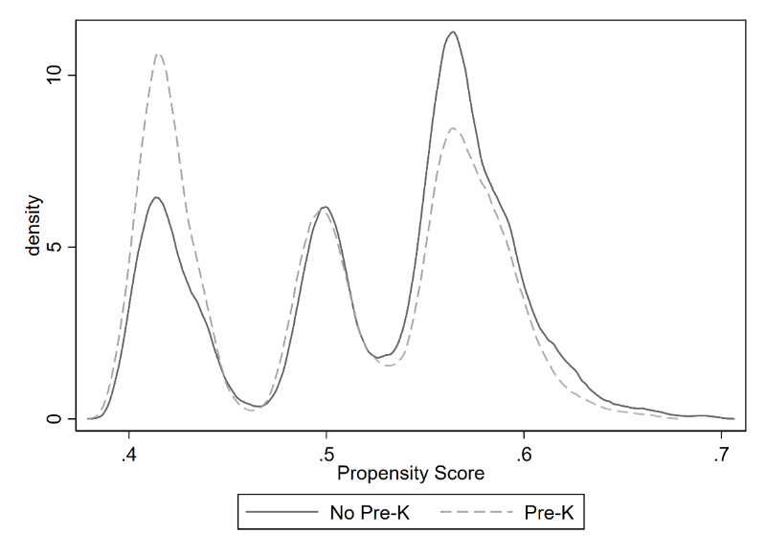
Note: Figure shows the area of common support by treatment level, i.e. no pre-K and pre-K.
Table 4: Balance
 | Standardized Differences |  | Variance Ratios
 | Raw | Weighted | Raw | Weighted
Female | .0049 | .0016 | 1.000 | .9999
Black | .2454 | .0019 | 1.242 | 1.001
Hispanic | .0212 | .0013 | 1.031 | 1.001
Asian | .0006 | .0007 | 1.005 | .9937
Native American | .0884 | .0009 | .7954 | .9973
NBH med. income | .1492 | .0017 | .6456 | .8355
% NBH with Some College | .1186 | .0034 | .8615 | .9576
Number of Obs. | 2,536 | 2,536
Treated | 1,232 | 1,268.3
Control | 1,204 | 1,267.7

Figure 2: Pre-K and Voting
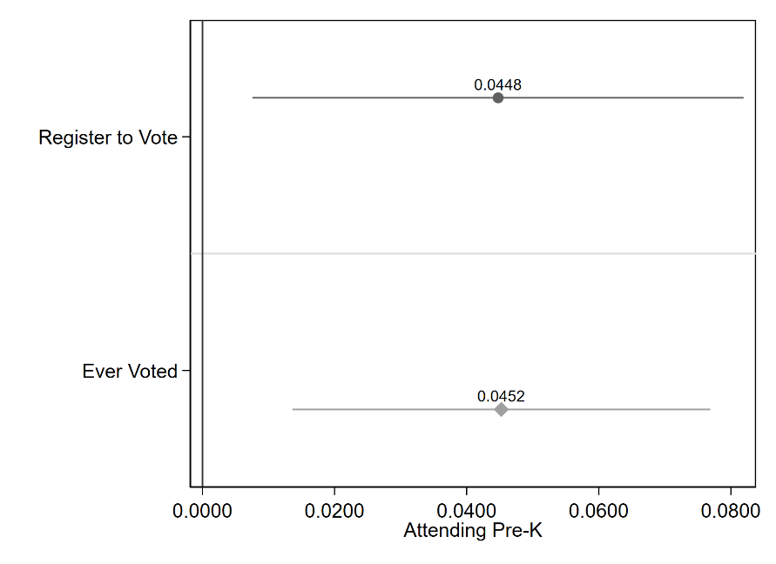
Note: The figure shows the coefficient and its 95% confidence interval for pre-K for two separate propensity score weighted models. The dependent variable for each model is on the x-axis.

Figure 3: Pre-K and Cognitive and Socio-Emotional Skills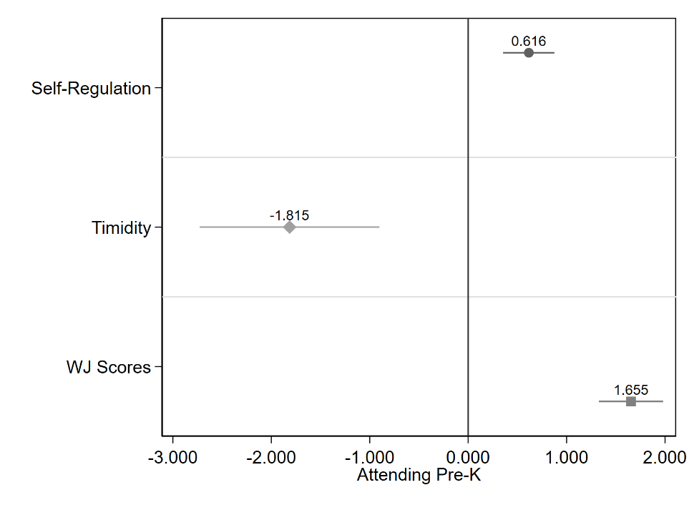
Note: The figure shows the coefficient and its 95% confidence interval for pre-K for three separate propensity score weighted models. The dependent variable for each model is on the x-axis.

Figure 4: Path Model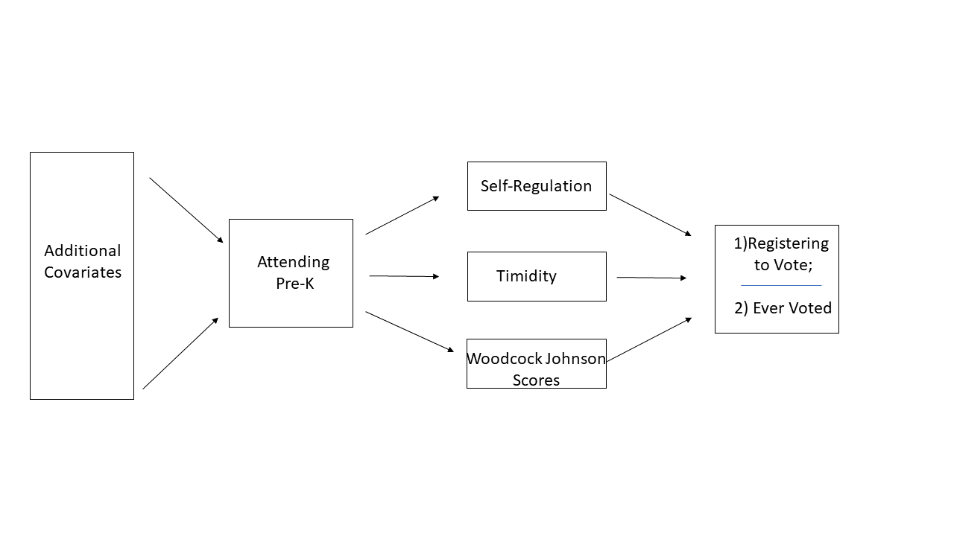

Table 5: Path Models
 | (1) | (2) | (3) | (4) | (5) | (6)
 | Pre-K | Self-Regulation | WJ Scores | Timidity | Registered to Vote | Ever Voted
Self-Regulation |  |  |  |  | 0.00 | 0.01**
 |  |  |  |  | (0.00) | (0.00)
WJ Scores |  |  |  |  | 0.02*** | 0.02***
 |  |  |  |  | (0.00) | (0.00)
Timidity |  |  |  |  | -0.00 | -0.00
 |  |  |  |  | (0.00) | (0.00)
Pre-K |  | 0.59*** | 1.59*** | -1.67***
 |  | (0.13) | (0.17) | (0.45)
Free Lunch |  | -0.89*** | -2.95*** | 2.88***
 |  | (0.17) | (0.21) | (0.55)
Reduce Lunch |  | -0.49** | -1.93*** | 2.02**
 |  | (0.24) | (0.31) | (0.84)
Redshirt |  | 0.41 | 1.57** | -1.65
 |  | (0.45) | (0.78) | (1.80)
NBH med. income |  | 0.13*** | 0.21*** | -0.17
 |  | (0.04) | (0.05) | (0.14)
% NBH with some college |  | 0.00 | 0.01 | 0.03**
 |  | (0.00) | (0.01) | (0.02)
Female | 0.01
 | (0.02)
Black | 0.15***
 | (0.02)
Hispanic | 0.07***
 | (0.03)
Native American | -0.00
 | (0.03)
Asian | 0.06
 | (0.08)
Constant | 0.42*** | 11.48*** | 10.88*** | 47.80*** | 0.14 | -0.08
 | (0.02) | (0.29) | (0.36) | (0.92) | (0.09) | (0.07)
Observations | 2,541 | 2,541 | 2,541 | 2,541 | 2,541 | 2,541
Robust standard errors in parentheses
*** p<0.01, ** p<0.05, * p<0.1

Appendix A: Results from Imputation and Propensity Score Weighting
As an additional robustness check, we expanded our set of covariates to include a much larger set to weight on. Because of missing data, we first imputed missing values and created 10 imputed data sets. Then we re-run our analysis with a larger set of covariates to improve propensity score weighting. Table A.1 shows the absolute standardized differences (ASD) between the control group (no pre-K) and the treatment group (pre-K) across each of the 10 imputations. Table A.2 shows the variance ratios across each of imputations. For all covariates, ASDs were reduced to near zero while variance ratios are all close to one.
Results from the propensity score weighted model with regression adjustment are shown in Figure A.1. The coefficients on pre-K are very similar to the model presented in the main paper. Pre-K increases the likelihood to register to vote by four percentage points, while increasing the likelihood of voting by four percentage points as well. Figure A.2 shows the coefficients on pre-K when predicting cognitive and socio-emotional skills. Results are very similar again. Lastly, Table A.3 shows the results from the two path models with the additional covariates. Both self-regulation and academic test scores are associated with an increased likelihood in voting.
As a final robustness check, we re-ran our propensity score weighting models and specified the treatment as students who attended either pre-K or Head Start. The control group would be student who attended neither. As Figure A.3 shows, results are very similar to the models that exclude Head Start students from the analysis.

Table A.1: Absolute Standardized Differences Across Imputations

 |  | Weighted
Variables: | Raw | 1 | 2 | 3 | 4 | 5 | 6 | 7 | 8 | 9 | 10
Female | 0.00 | 0.00 | 0.01 | 0.01 | 0.00 | 0.00 | 0.00 | 0.01 | 0.00 | 0.01 | 0.00
Black | 0.25 | 0.00 | 0.01 | 0.02 | 0.00 | 0.00 | 0.01 | 0.01 | 0.01 | 0.01 | 0.01
Hispanic | 0.02 | 0.01 | 0.00 | 0.01 | 0.02 | 0.02 | 0.00 | 0.01 | 0.01 | 0.01 | 0.00
Asian | 0.00 | 0.01 | 0.00 | 0.00 | 0.00 | 0.01 | 0.00 | 0.02 | 0.01 | 0.00 | 0.01
Native American | 0.09 | 0.00 | 0.01 | 0.01 | 0.01 | 0.01 | 0.00 | 0.01 | 0.01 | 0.01 | 0.01
Red Shirt | 0.15 | 0.00 | 0.00 | 0.01 | 0.00 | 0.00 | 0.00 | 0.01 | 0.00 | 0.00 | 0.01
Reduced Lunch | 0.06 | 0.01 | 0.01 | 0.01 | 0.01 | 0.01 | 0.00 | 0.01 | 0.01 | 0.00 | 0.01
Paid Lunch | 0.07 | 0.01 | 0.01 | 0.01 | 0.01 | 0.00 | 0.01 | 0.01 | 0.00 | 0.01 | 0.01
NHD Med Income | 0.15 | 0.00 | 0.01 | 0.00 | 0.00 | 0.00 | 0.00 | 0.00 | 0.00 | 0.00 | 0.00
% Some College | 0.12 | 0.00 | 0.00 | 0.01 | 0.01 | 0.00 | 0.01 | 0.01 | 0.01 | 0.01 | 0.01
Lives w/father | 0.20 | 0.01 | 0.00 | 0.01 | 0.01 | 0.01 | 0.01 | 0.00 | 0.00 | 0.01 | 0.00
Internet | 0.10 | 0.02 | 0.01 | 0.00 | 0.02 | 0.01 | 0.01 | 0.01 | 0.00 | 0.01 | 0.01
Foreign Born | 0.12 | 0.00 | 0.01 | 0.01 | 0.01 | 0.00 | 0.01 | 0.00 | 0.01 | 0.00 | 0.01
English | 0.08 | 0.01 | 0.00 | 0.01 | 0.02 | 0.01 | 0.00 | 0.01 | 0.01 | 0.01 | 0.00
Married | 0.18 | 0.00 | 0.01 | 0.01 | 0.00 | 0.01 | 0.02 | 0.01 | 0.00 | 0.01 | 0.01
Remarried | 0.05 | 0.01 | 0.00 | 0.01 | 0.00 | 0.01 | 0.00 | 0.00 | 0.00 | 0.00 | 0.00
Separated | 0.08 | 0.00 | 0.01 | 0.00 | 0.00 | 0.00 | 0.00 | 0.01 | 0.02 | 0.00 | 0.01
Divorced | 0.14 | 0.01 | 0.02 | 0.01 | 0.01 | 0.01 | 0.00 | 0.01 | 0.01 | 0.00 | 0.00
Widowed | 0.07 | 0.00 | 0.00 | 0.01 | 0.00 | 0.01 | 0.01 | 0.01 | 0.01 | 0.00 | 0.00
Mom High School | 0.02 | 0.00 | 0.00 | 0.02 | 0.01 | 0.00 | 0.01 | 0.01 | 0.01 | 0.00 | 0.00
Mom Some Col. | 0.04 | 0.00 | 0.00 | 0.02 | 0.01 | 0.01 | 0.01 | 0.01 | 0.01 | 0.01 | 0.01
Mom College | 0.02 | 0.02 | 0.01 | 0.02 | 0.01 | 0.00 | 0.02 | 0.01 | 0.00 | 0.01 | 0.01
Number of obs. | 2,540 | 2,540 | 2,540 | 2,540 | 2,540 | 2,540 | 2,540 | 2,540 | 2,540 | 2,540 | 2,540
Treated obs. | 1,234 | 1,270.9 | 1,266.9 | 1,268.9 | 1,270.0 | 1,270.8 | 1,272.3 | 1,270.3 | 1,270.9 | 1,270.5 | 1,270.4
Control obs. | 1,306 | 1,269.1 | 1,273.1 | 1,271.1 | 1,270.0 | 1,269.2 | 1,267.7 | 1,269.7 | 1,269.1 | 1,269.5 | 1,269.6
Table A.2: Variance Ratio Across Imputations

 |  | Weighted
 | Raw | 1 | 2 | 3 | 4 | 5 | 6 | 7 | 8 | 9 | 10
Female | 1.00 | 1.00 | 1.00 | 1.00 | 1.00 | 1.00 | 1.00 | 1.00 | 1.00 | 1.00 | 1.00
Black | 1.24 | 1.00 | 0.99 | 0.99 | 1.00 | 1.00 | 1.00 | 1.00 | 1.00 | 0.99 | 0.99
Hispanic | 1.03 | 0.99 | 0.99 | 0.98 | 0.98 | 0.98 | 1.00 | 0.99 | 0.98 | 0.99 | 1.00
Asian | 1.01 | 1.11 | 1.02 | 1.04 | 1.01 | 1.07 | 1.04 | 1.18 | 1.04 | 1.03 | 1.07
Native American | 0.80 | 1.01 | 1.01 | 1.03 | 1.02 | 1.04 | 1.00 | 1.03 | 1.03 | 1.03 | 1.01
Red Shirt | 0.25 | 0.95 | 0.97 | 0.93 | 0.96 | 0.97 | 0.94 | 0.93 | 0.95 | 1.01 | 0.91
Reduced Price Lunch | 1.17 | 0.97 | 0.97 | 0.98 | 0.98 | 0.98 | 0.99 | 0.98 | 0.97 | 1.00 | 0.97
Paid Lunch | 0.93 | 1.01 | 1.01 | 1.01 | 1.01 | 1.00 | 1.01 | 1.01 | 1.00 | 1.01 | 1.01
NHD Med Income | 0.65 | 0.87 | 0.87 | 0.87 | 0.90 | 0.88 | 0.88 | 0.88 | 0.88 | 0.84 | 0.87
% Some College | 0.86 | 0.96 | 0.96 | 0.97 | 0.95 | 0.96 | 0.95 | 0.95 | 0.96 | 0.95 | 0.96
Lives with father | 0.94 | 1.00 | 1.00 | 1.00 | 1.01 | 1.00 | 1.00 | 1.00 | 1.00 | 1.00 | 1.00
Internet | 1.00 | 1.00 | 1.00 | 1.00 | 1.00 | 1.00 | 1.00 | 1.00 | 1.00 | 1.00 | 1.00
Foreign Born | 1.22 | 1.00 | 0.99 | 1.02 | 0.99 | 1.00 | 1.02 | 1.01 | 1.02 | 1.01 | 1.01
English | 1.18 | 0.99 | 0.99 | 0.97 | 0.97 | 0.98 | 1.00 | 0.99 | 0.98 | 0.98 | 1.00
Married | 0.98 | 1.00 | 1.00 | 1.00 | 1.00 | 1.00 | 1.00 | 1.00 | 1.00 | 1.00 | 1.00
Remarried | 0.75 | 1.03 | 1.00 | 1.04 | 1.00 | 1.06 | 1.00 | 1.02 | 1.00 | 1.01 | 0.98
Separated | 0.73 | 0.99 | 0.98 | 1.02 | 1.00 | 0.98 | 0.98 | 0.97 | 0.92 | 0.99 | 0.97
Divorced | 0.70 | 1.02 | 1.06 | 1.03 | 1.03 | 1.02 | 1.01 | 1.05 | 1.03 | 1.01 | 1.01
Widowed | 0.57 | 1.03 | 1.03 | 0.91 | 1.02 | 1.09 | 0.95 | 0.92 | 1.09 | 1.00 | 0.99
Mom High School | 0.98 | 1.00 | 1.00 | 1.02 | 1.01 | 1.00 | 1.01 | 1.01 | 1.01 | 1.00 | 1.00
Mom Some Col. | 1.02 | 1.00 | 1.00 | 1.00 | 1.00 | 1.01 | 1.00 | 1.00 | 1.00 | 1.00 | 1.00
Mom College | 0.95 | 1.04 | 1.02 | 1.03 | 1.03 | 1.00 | 1.04 | 0.98 | 1.01 | 1.01 | 1.02

Figure A.1: Pre-K Attendance on Voting
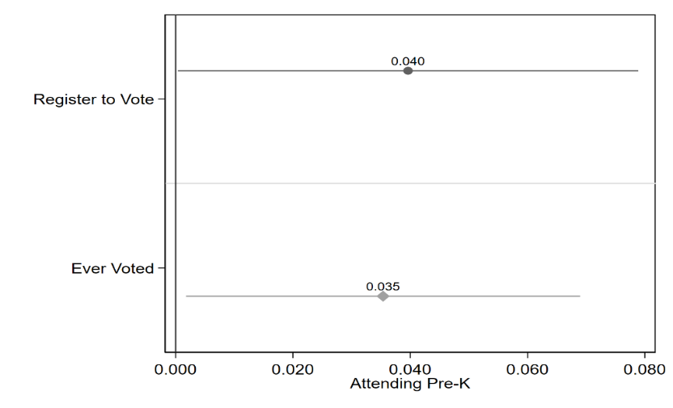
Note: The coefficient on pre-K and its 95% confidence interval from the propensity score weighting models are plotted.
Figure A.2: Pre-K Attendance on Cognitive and Socio-Emotional Skills
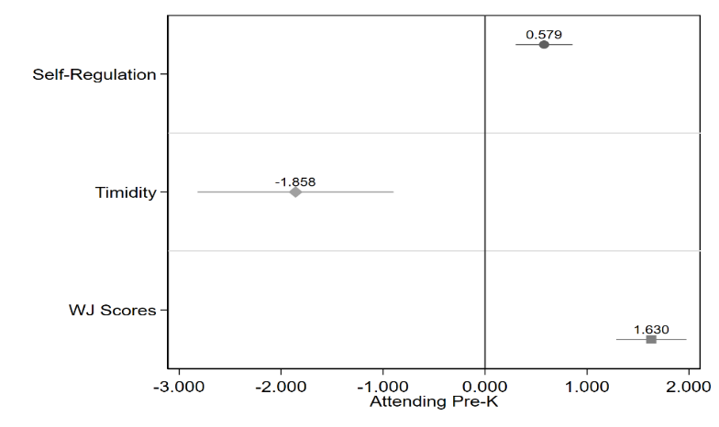
Note: The coefficient on pre-K and its 95% confidence interval from the propensity score weighting models are plotted.

Figure A.3: Pre-K Attendance on Voting using kindergarten fixed effects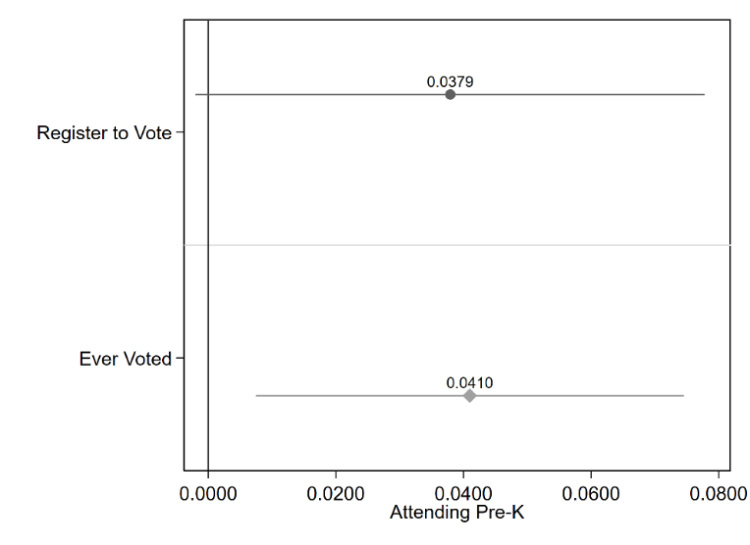
Note: The coefficient on pre-K and its 95% confidence interval from the propensity score weighting models are plotted. This model includes fixed effects for schools at kindergarten.

Figure A.4: Pre-K Attendance on Voting using school district fixed effects
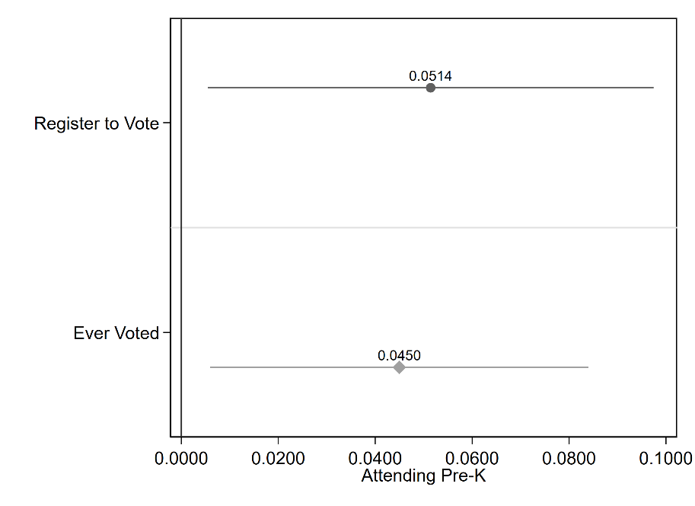
Note: The coefficient on pre-K and its 95% confidence interval from the propensity score weighting models are plotted. This model includes fixed effects for school district at high school.

Figure A.5: Results for Combining Pre-K and Head Start into the same group
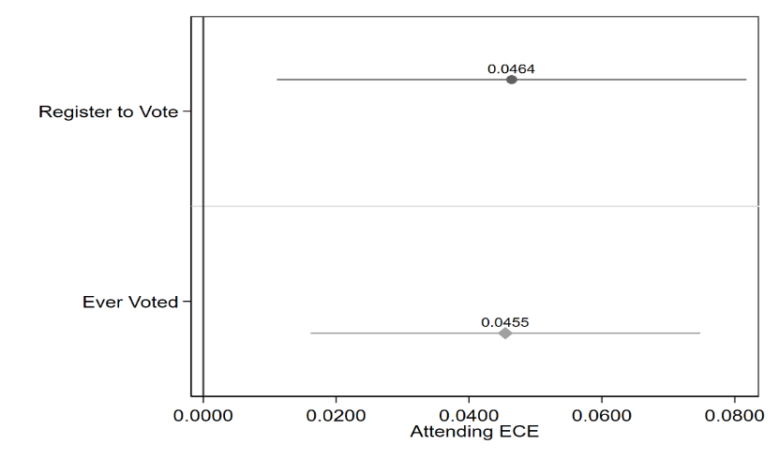
Note: The coefficient on pre-K and its 95% confidence interval from the propensity score weighting models are plotted.

Table A.3: Path Models with Imputed Data
 | (1) | (2) | (3) | (4) | (5) | (5)
VARIABLES | Pre-K | Self-Reg. | WJ Scores | Timidity | Registered | Voted
Self-Regulation |  |  |  |  | 0.00 | 0.01**
 |  |  |  |  | (0.00) | (0.00)
WJ Scores |  |  |  |  | 0.02*** | 0.02***
 |  |  |  |  | (0.00) | (0.00)
Timidity |  |  |  |  | -0.00 | -0.00
 |  |  |  |  | (0.00) | (0.00)
Female | 0.01
 | (0.02)
Black | 0.21***
 | (0.03)
Hispanic | 0.07**
 | (0.03)
Native American | 0.01
 | (0.03)
Asian | 0.05
 | (0.08)
Mother Some College | -0.01
 | (0.03)
Mother College & Up | -0.09**
 | (0.04)
Lives with Father | 0.07**
 | (0.03)
Internet | 0.09***
 | (0.03)
Married | 0.08**
 | (0.03)
Pre-K |  | 0.59*** | 1.59*** | -1.67***
 |  | (0.13) | (0.17) | (0.45)
Free Lunch |  | -0.89*** | -2.95*** | 2.87***
 |  | (0.17) | (0.21) | (0.55)
Reduced Lunch |  | -0.49** | -1.93*** | 2.01**
 |  | (0.24) | (0.31) | (0.84)
Redshirt |  | 0.41 | 1.57** | -1.65
 |  | (0.45) | (0.78) | (1.80)
NBH median income |  | 0.13*** | 0.21*** | -0.17
 |  | (0.04) | (0.05) | (0.14)
% NBH Some Col. |  | 0.00 | 0.01 | 0.03**
 |  | (0.00) | (0.01) | (0.02)
Constant | 0.29*** | 11.48*** | 10.88*** | 47.80*** | 0.14 | -0.08
 | (0.03) | (0.29) | (0.36) | (0.92) | (0.09) | (0.07)
Observations | 2,541 | 2,541 | 2,541 | 2,541 | 2,541 | 2,541
Robust standard errors in parentheses
*** p<0.01, ** p<0.05, * p<0.1
Table A.4: Path Models with Magnet School Attendance
 | (1) | (2) | (3) | (4) | (5) | (6) | (7)
VARIABLES | Pre-K | Self-Reg. | WJ Scores | Timidity | Magnet | Registered | Voted
Magnet |  |  |  |  |  | 0.26*** | 0.25***
 |  |  |  |  |  | (0.03) | (0.02)
Self-Regulation |  |  |  |  | 0.02***
 |  |  |  |  | (0.01)
WJ Scores |  |  |  |  | 0.04***
 |  |  |  |  | (0.00)
Timidity |  |  |  |  | -0.00
 |  |  |  |  | (0.00)
Pre-K |  | 0.81*** | 1.85*** | -2.60***
 |  | (0.18) | (0.23) | (0.65)
Free Lunch |  | -1.00*** | -3.52*** | 2.83***
 |  | (0.23) | (0.31) | (0.74)
Reduce Lunch |  | -0.76** | -2.41*** | 3.85***
 |  | (0.33) | (0.45) | (1.30)
Redshirt |  | -0.09 | 1.30 | -1.51
 |  | (0.49) | (0.90) | (2.12)
NBH med. income |  | 0.20*** | 0.22*** | -0.17
 |  | (0.05) | (0.07) | (0.20)
% NBH Some College |  | -0.00 | 0.01 | 0.01
 |  | (0.01) | (0.01) | (0.02)
Female | 0.01
 | (0.03)
Black | 0.18***
 | (0.03)
Hispanic | 0.08**
 | (0.04)
Native American | 0.01
 | (0.05)
Asian | 0.15
 | (0.10)
Constant | 0.44*** | 11.41*** | 10.91*** | 49.76*** | -0.13 | 0.29*** | 0.16***
 | (0.03) | (0.38) | (0.52) | (1.27) | (0.11) | (0.02) | (0.01)
Observations | 1,354 | 1,354 | 1,354 | 1,354 | 1,354 | 1,354 | 1,354
Robust standard errors in parentheses
*** p<0.01, ** p<0.05, * p<0.1

karin@vt.edu
This date was chosen because it is the most comprehensive data pull from the state that we have.
Oklahoma does not have same day voter registration.
If a person legally changed their name (i.e. because they married), we would not know this. We believe that this does happen but does not occur frequently, for the age group in question.
We are using the teffects ipwra command in STATA and specifying robust standard errors.
For these models, we use the structural equation model command in STATA: sem. Robust standard errors are specified. The method of estimation is maximum likelihood with missing values.

